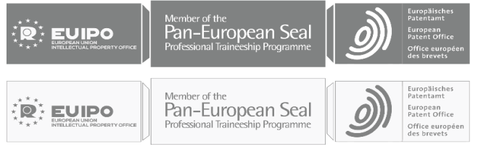

Alicante, Spain 2023
CALL FOR EXPRESSIONS OF INTEREST
To join the Research Visits at the EUIPO (under the scope of the NIPA)
ANNEX 1
APPLICATION FORM
Please send the completed application form to Pan_European_Seal@euipo.europa.eu, with ‘Research Visits (NIPA) – call for expressions of interest’ in the subject line.
*Mandatory fields
Name and Surname*
Network of Intellectual Property Academies Member *
(PES University, Talent Bank Associated Partner, etc.)
Current Position*
Main area of expertise and professional experience relevant to the Research Visit*
E-mail*
Phone*
City*
Address*
Website URL
General Location | - EU  - Non-EU
Nationality
Indicate (√) the desired duration of the Research Visit*:  Short Term Visit lasts from 1 to 5 days (maximum)  Long Term Visit lasts from 15 days to 2 months (maximum) | - Short Term Visit  - 1 day  - 2 days  - 3 days  - 4 days  - 5 days  - Long Term Visit  - 15 days  - 1 month  - 1,5 months  - 2 months  IMPORTANT: Long Term Visits can either start at the beginning (1st – 5th) or the middle (15th – 18th)of the respective month.
Please indicate the exact dates you would like to visit*. | Day / Month / Year
Indicate whether and which EUIPO expert(s) by knowledge area/Department/Service you would like to consult.  (Applicable only for Long Term Research Visit) | YES NO  EUIPO Department/Service___________________________
Indicate the exact material you would like the EUIPO Library to acquire for your Visit.
Please describe in maximum 200 words your research topic and the main aim of your Research Visit*.

